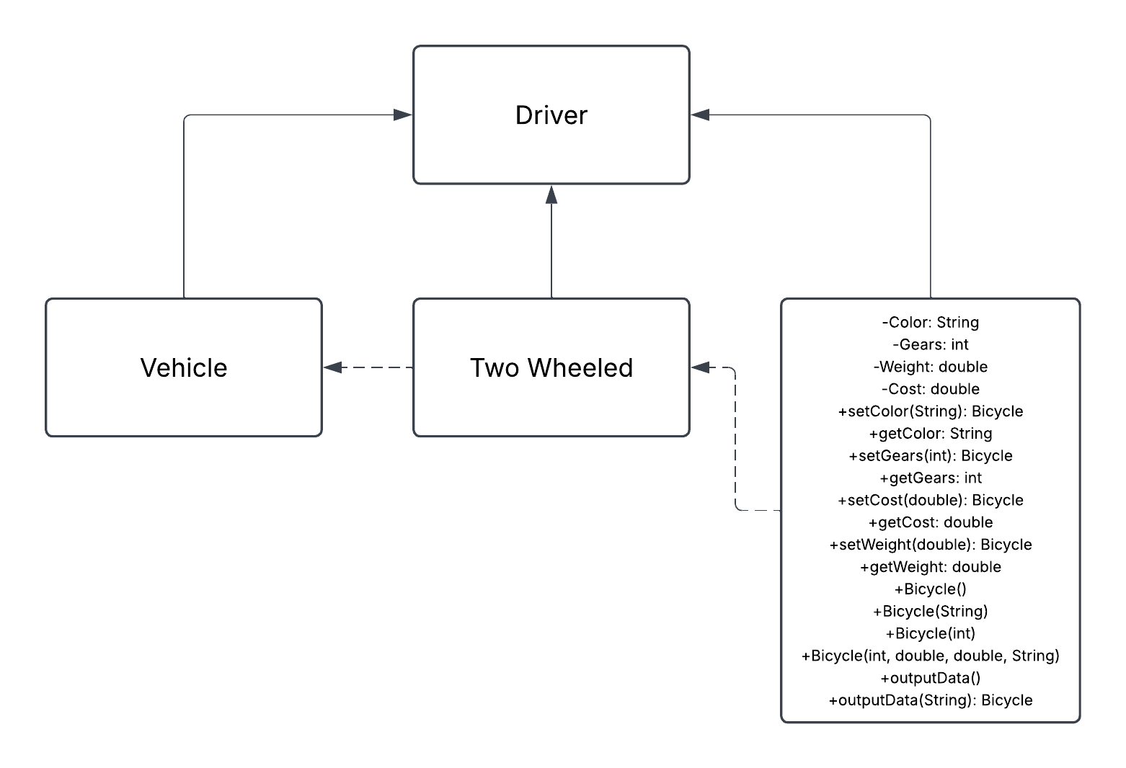
It is my belief that this diagram represents an OOP Abstract Diagram. This is largely based on the representation of the Two-Wheeled sub-class being classified as a vehicle, but also as the parent class of a bicycle. There is also the subclass that gives the relevant information regarding structure (i.e. color, gears, and weight) and cost of the item, but not how to use it (Inheritance), does not restrict full information (Encapsulation), and does not alter behavior by class or action (Polymorphism). This UML OOP simply states the attributes of the Bicycle and subclass descriptions, creating a more abstract “appearance” of the item. Due to this, many aspects can be altered within the data entry section without affecting the parent class, making it so that code will still work if items in the two-wheeled or driver class are altered. The output would be the primary altered information, allowing for a semblance of customization.

